I love how it is starting to get light out when I wake up and that I can still see the glow of a sinking sun when I take my dog, Linus, out for his last walk of the evening. As I look around the property, I want to get going on all of the outdoor projects I have in my head—along with the trees, bushes, and seeds sitting in a holding pattern in my sunroom and just outside my home.
“Let’s do this!” is what my optimistic self says. But the weather report is calling once again for possible snow showers overnight in the mountains. Really? Yes, really.
Living in the mountains is beautiful. I truly think we have the best clouds and summers anywhere—but we pay for that beauty with a very short growing season. Memorial Day is the unofficial “safe” time to plant many things here. That’s very different from the Midwest, where April and May bloomed quite literally with flowers, and I would have already planted containers on my patio by now.
That all being said, as I unloaded 12 bags of mulch the other weekend to have ready when the time comes, I found myself coaching myself to move carefully and remember to do all the things I know—but may be a little out of practice after winter.
You see, even though I lift weights, keep moving during the winter, and walk daily, moving for spring outdoor activities is a different skill set than moving for winter.
Preparing your muscles and joints ahead of time is one of the simplest and most effective ways to protect your body, prevent injuries, and fully enjoy the outdoor activities you’ve been waiting all winter to do.
Before jumping into projects full speed, take a few minutes to prepare your body. Warming up before physical activity can reduce injury risk by 30–50% (Fradkin, Zazryn, & Smoliga, 2010). These six exercises are a simple way to get started.

1) Sit-to-Stand (Chair Squat)
Purpose: Prepares hips, knees, and core for lifting, climbing stairs, and getting up from low surfaces.

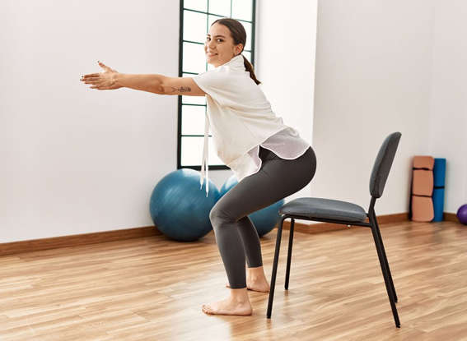

Why it prepares the body:
This movement strengthens the major muscles that stabilize the knee and hip joints—especially important before activities like gardening, hiking, and yard work.
Coaching cue:
Press through your heels and stand tall. Control the lowering phase.

2) Heel Raises (Calf Raises)
Purpose: Prepares ankles and lower legs for walking, uneven ground, and balance.


Why it prepares the body:
Strong calf muscles help absorb impact and stabilize the ankle joint, reducing fall risk and improving walking endurance.
Coaching cue:
Rise slowly onto your toes, pause briefly, and lower with control.

3) Wall Push-Ups
Purpose: Prepares shoulders, chest, and arms for pushing, lifting, and carrying.

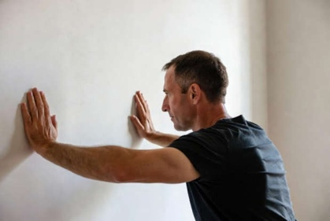

Why it prepares the body:
This exercise strengthens the muscles that support the shoulder joint, improving stability before tasks like lifting bags, pushing lawn equipment, or carrying supplies.
Coaching cue:
Keep your body in a straight line from head to heels.

4) Hip Hinge (Hands on Thighs)
Purpose: Prepares the hips and spine for bending and lifting safely.

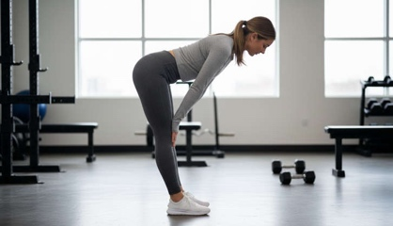
Why it prepares the body:
Practicing the hip hinge teaches the body to use the hips instead of the lower back during lifting and bending.
Coaching cue:
Keep your spine long and hinge from the hips—not the waist.

5) Shoulder Rolls
Purpose: Prepares shoulder joints and upper back for reaching and carrying.


Why it prepares the body:
Gentle shoulder movement increases circulation and mobility in the joint before activity.
Coaching cue:
Move slowly and smoothly. Breathe naturally.

6) March in Place
Purpose: Prepares the whole body for movement and improves coordination.

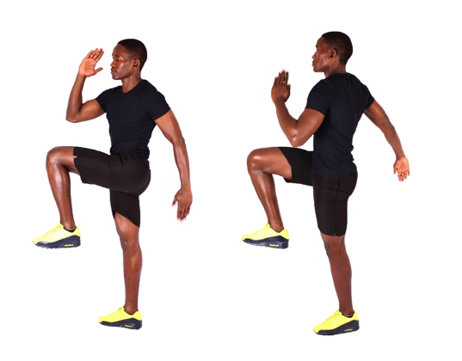
Why it prepares the body:
This simple movement activates the hips, core, and legs while increasing blood flow to muscles and joints.
Coaching cue:
Lift one knee at a time and maintain steady posture.
A few minutes of preparation today can help you stay strong, safe, and active all season long.
Move Stronger. Live Better. Thrive.
— Ginger & Oak Co.

Image Credit:
Images are sourced from Creative Commons on Google and are used for educational purposes.
Disclaimer:
This article is intended for general educational purposes only and is not a substitute for professional medical advice, diagnosis, or treatment. Always consult with your physician or other qualified health professional before beginning any new exercise or physical activity program.

